SCOPED APPLICATION INSTALLATION AND CONFIGURATION GUIDE
Genesys Cloud Connector - External Routing

Table of Contents
1. Overview 3
2. Application Dependencies 3
3. Steps to Request for plugin from ServiceNow Store. 3
4. Genesys Cloud Configuration In this section, we will detail the genesys cloud configurations needed for the Genesys External Routing. 4
5. Configuration Instructions In this section, we will detail the exact steps required to configure the External Routing integration in ServiceNow instance. 10
6. Support and Troubleshooting 14

- Overview
Overview
Genesys External Routing enables ServiceNow platform to leverage Genesys Cloud routing capabilities for routing cases, incidents and chat interactions. Genesys External Routing amplifies the existing Genesys Cloud Connector capabilities and adds on the routing feature for all the ServiceNow interactions and work items. Genesys External Routing is compatible with workspace supported by Genesys Cloud Connector i.e.
- ITSM
- CSM/FSM Configurable Workspace
- Service Operation Workspace
- HR Agent workspace

This document outlines the step-by-step process for setting up the Genesys External Routing, empowering users to effectively leverage its capabilities.

- Application Dependencies
- ServiceNow plugins required:
  - Genesys Cloud Connector
  - Advanced Work Assignment
  - Agent Chat (required if handling chat interactions)

- System table permissions required:
  - awa_agent_presence
  - awa_work_item
  - interaction
  - incident (for ITSM workspace)
  - sn_customerservice_case (for CSM workspace)

- Steps to Request for plugin from ServiceNow Store.
  - Go to service now store https://store.servicenow.com/sn_appstore_store.do#!/store/home.
  - Search for 'Genesys External Routing' and select the app.
  - Click on 'Request App'. A Request will be sent to Genesys team for approval.
  - Once your request is approved, please go to the plugins section in ServiceNow instance.

- Genesys Cloud Configuration
In this section, we will detail the genesys cloud configurations needed for the Genesys External Routing.
  - Under Admin Console in Genesys Cloud, search for “Platform”
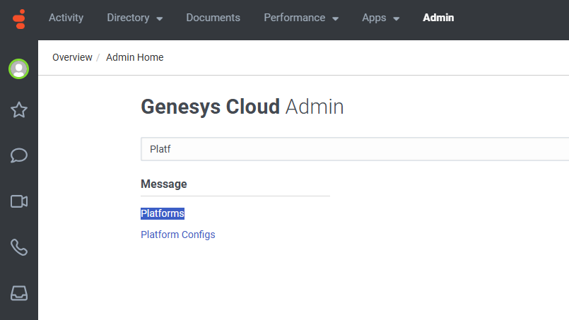
    - Click on Platforms and then click on “Create New Integration” button.
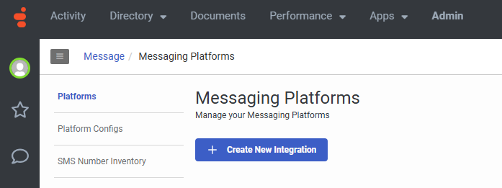
    - Select “Open Messaging”
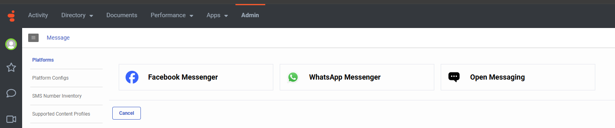
    - Fill the form
Note: Outbound Notification Webhook URL & Signature Secret Token are required fields but can be populated with some placeholder values as the solution doesn’t uses webhook as of now.
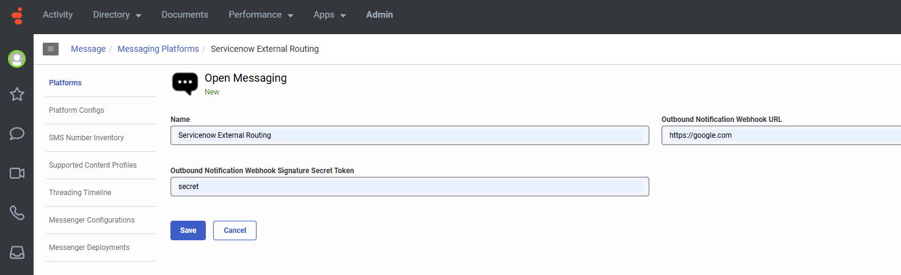
    - Click on save.
    - After saving, please save the highlighted value below. It is the Integration Id which we will need to configure our application in ServiceNow.
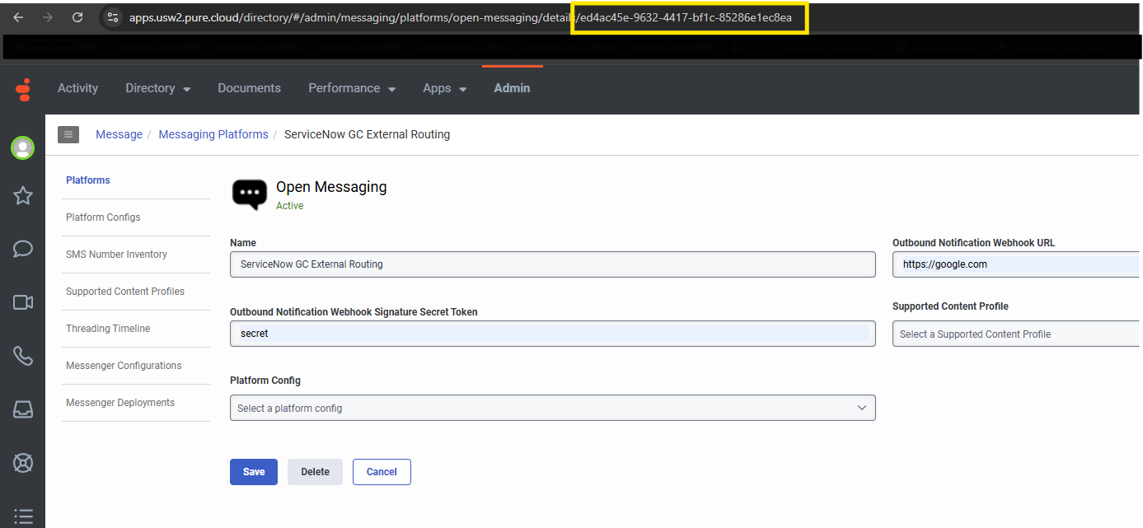
  - Under Admin Console in Genesys Cloud, search for “Architect”.
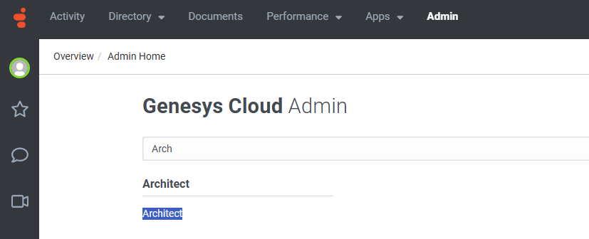
    - Click on “Architect” and select “Inbound Message” under Flows.
    - Click on “Add” and fill out the form.
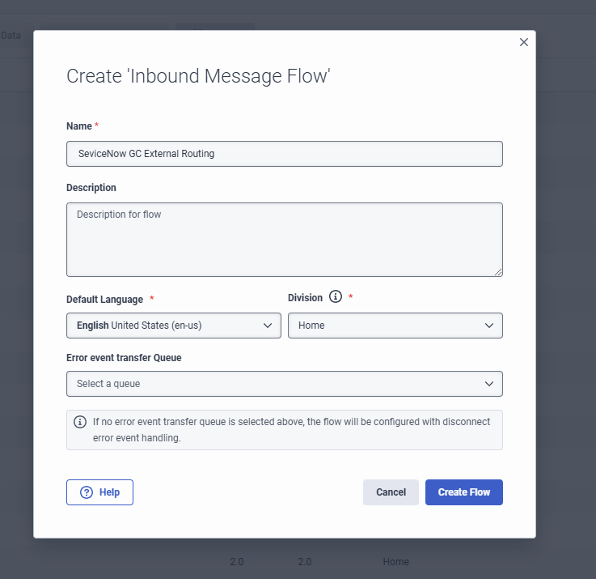
    - Configure the architect flow to “Transfer to ACD” and select a desired queue for agent assignment.
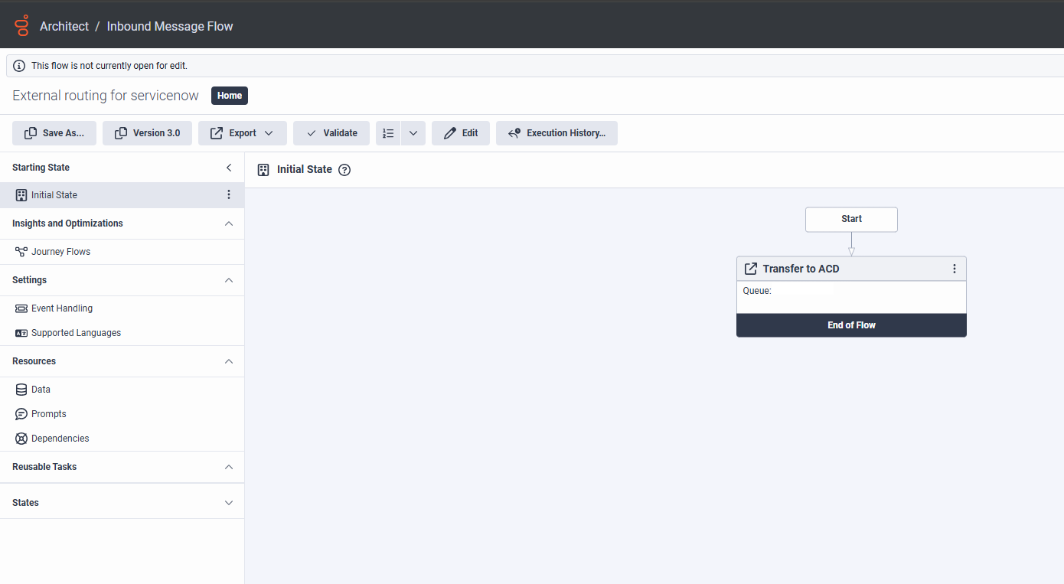
  - Under Admin Console in Genesys Cloud, search for “Message Routing”.
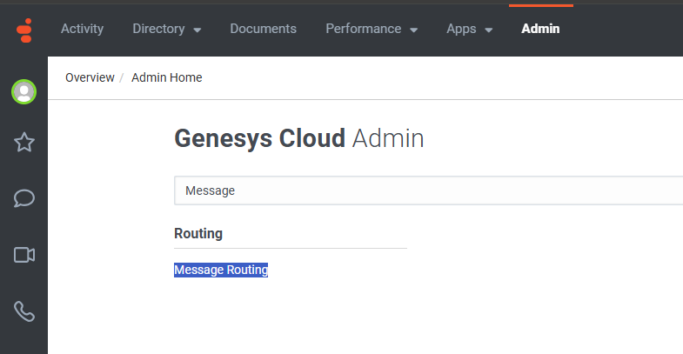
    - Click on “Attach New Addresses to a Flow”.
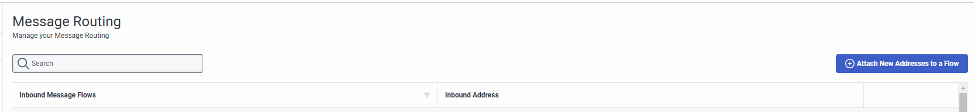
    - Under “Select a Flow”, search and select the Inbound Message Flow created above and similarly under “Select Addresses”, search and select the Message platform created above.
    - Click on “Attach Address”.
  - Under Admin Console in Genesys Cloud, search for “OAuth”.
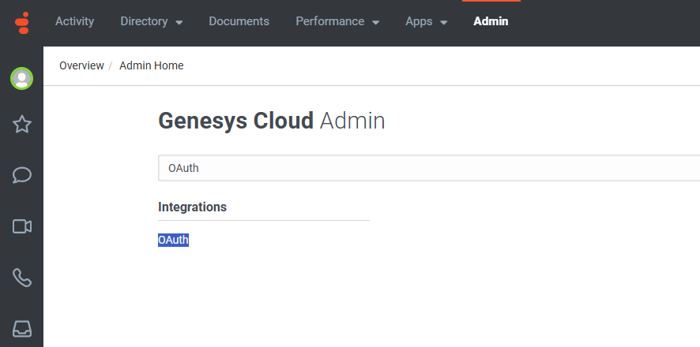
    - Click on “OAuth” and then click on “Add Client”.
    - Fill the form and select grant type “Client Credentials”.
    - Click on “Save”.
    - Under Client Details, we can find the client Id and client secret.
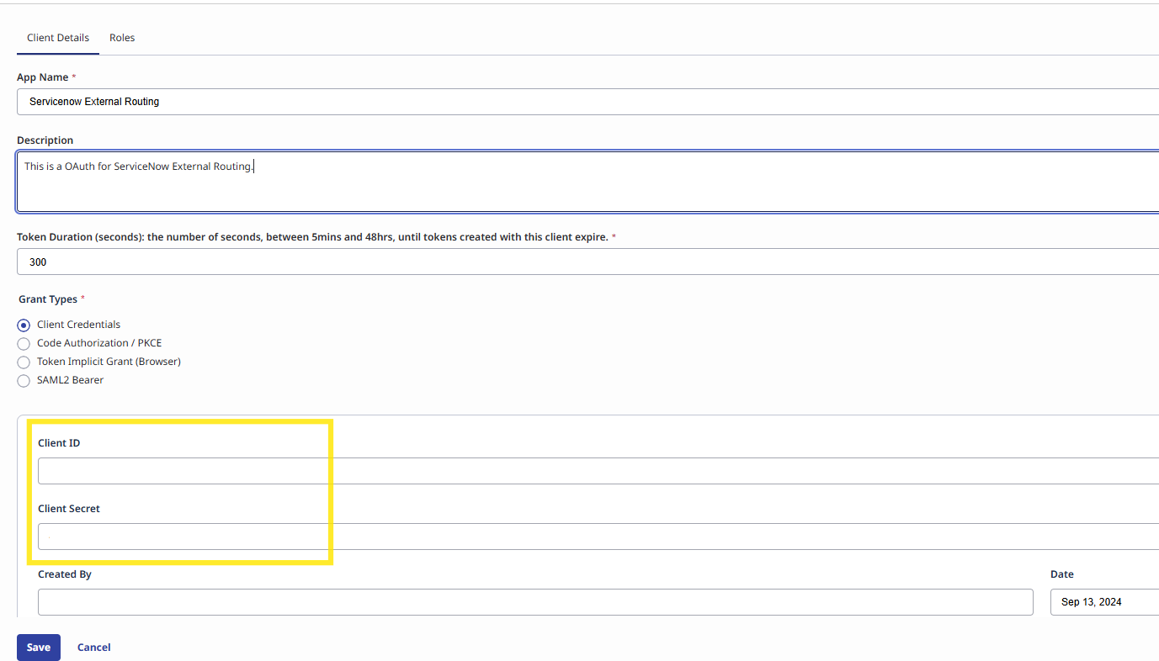
- Configuration Instructions
In this section, we will detail the exact steps required to configure the External Routing integration in ServiceNow instance.
  - Verify External Routing application is successfully installed.
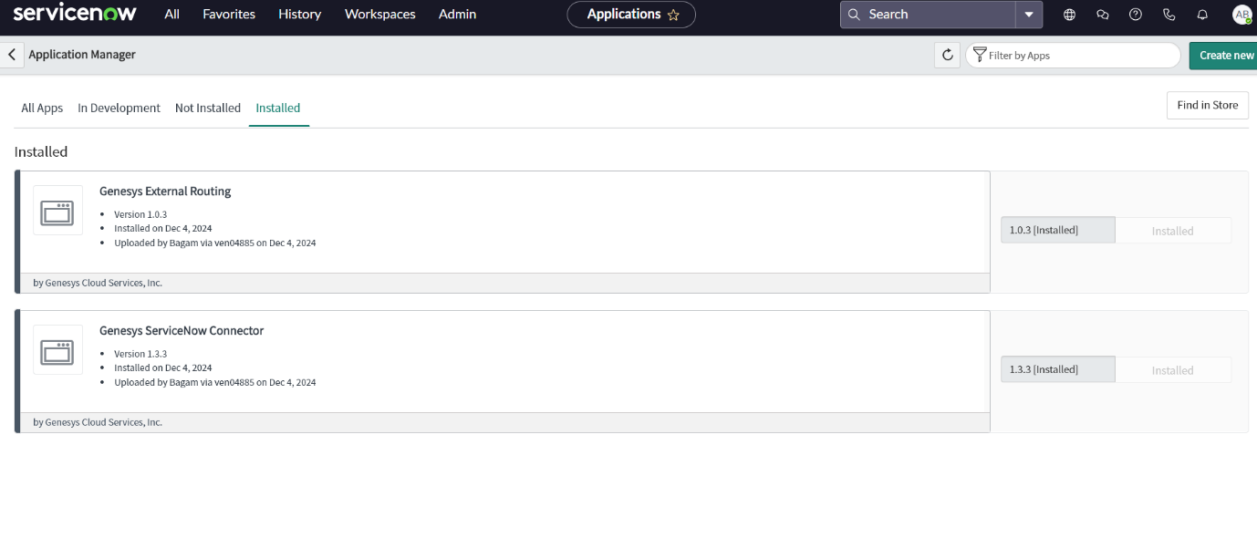
  - Navigate to the Genesys External Routing
    - You will notice a warning icon. Toggle the switch to activate the Genesys Cloud Connector.
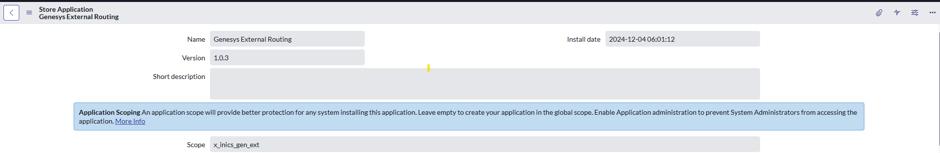
  - Navigate to "System Definition" in the Filter Navigator and select "Script Include".
    - Verify whether the "genesys_rest_api" file has been created.
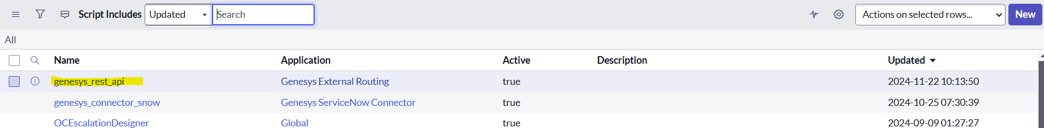
  - Use the Filter Navigator to search for "UI Scripts" and click on it.
    - Verify whether the “x_inics_gen_ext.genesys_external_routing” file has been created.
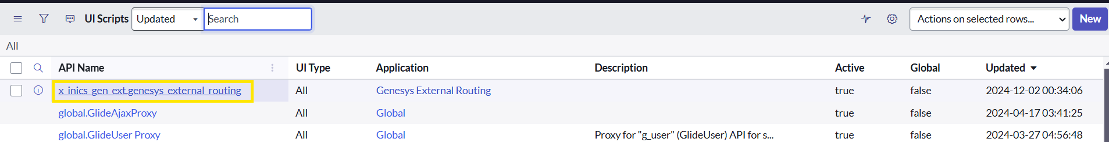
  - Use the Filter Navigator to search for "Business Rules" under System Definition and click on it.
    - Verify whether the “Genesys Route Work Items” file has been created.
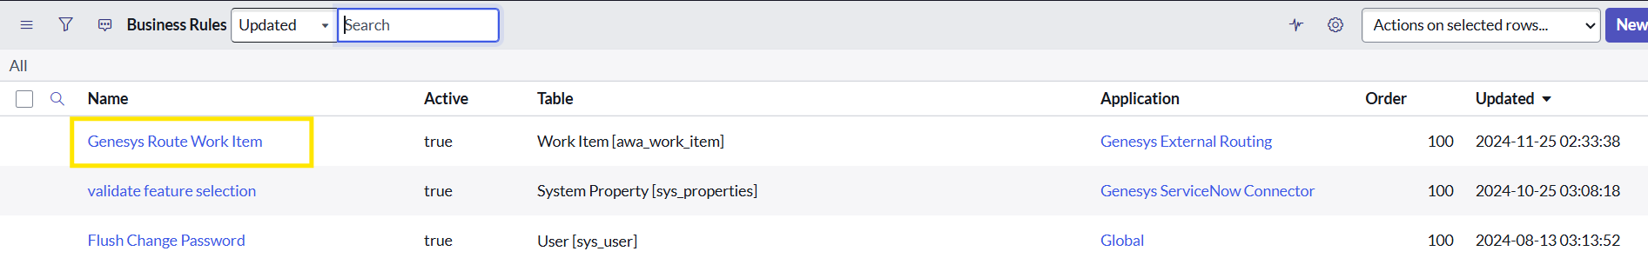
  - Use the Filter Navigator to search for "Application Registry" under System OAuth and click on it.
    - Create a new record by clicking “New” button on top right corner. When prompted with “What kind of OAuth Application”, select “Connect to a third-party OAuth Provider”.
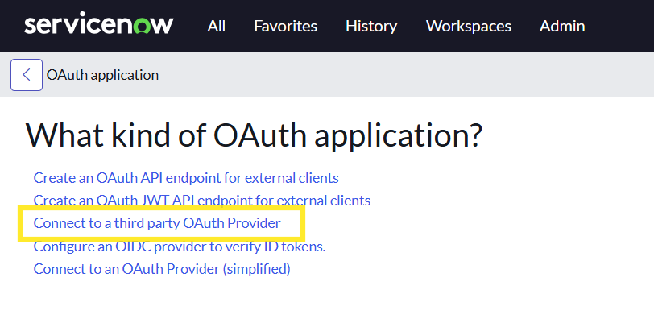
    - Fill the form with the required information below:
      - Name: Genesys External Routing
      - Client ID: Paste value from Genesys OAuth (refer 4.4.4 ).
      - Client Secret: Paste Value from Genesys OAuth (refer 4.4.4 ).
      - Default Grant Type: Select “Client Credentials” from the dropdown options.
      - Refresh Token Lifespan: Choose a lifespan in seconds.
      - Token URL: Please insert the URL as https://login.<gcEnv>/oauth/token. Value for <gcEnv> should be the genesys environment client is using. For example – mypurecloud.com
      - Authorization URL: Please insert the URL as https://login.<gcEnv>/oauth/authorize. Value for <gcEnv> should be the genesys environment client is using. For example – mypurecloud.com
      - Send Credentials: Select “As Basic Authorization Header” from dropdown options.
      - Accessible from: Select “This Application Scope Only” from dropdown options.
      - Active: Click checkbox to mark true.
      - Click Submit
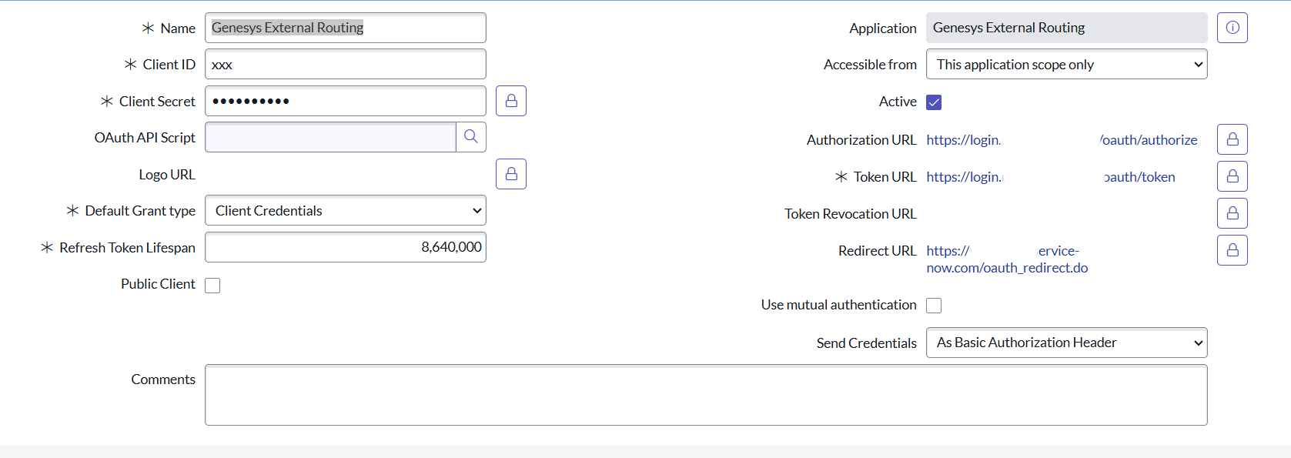
Ensure that a default OAuth Entity profile has been created.
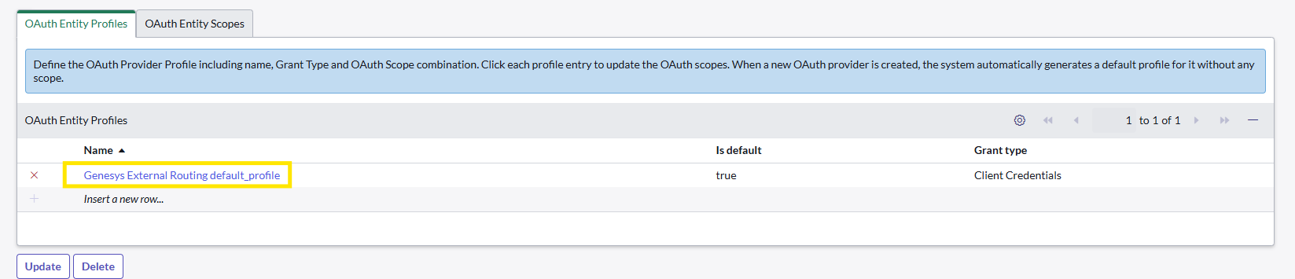
  - Use the Filter Navigator to search for "REST Message" under “System Web Services > Outbound” and click on it.
    - Verify whether the “Genesys External Routing” file has been created.
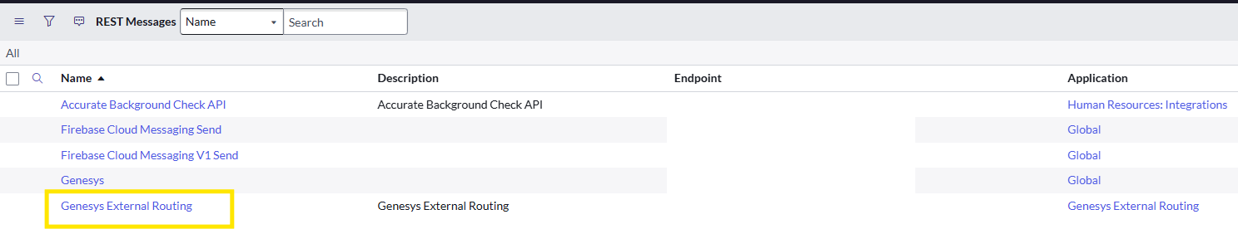
    - Click on it and ensure that the endpoint and OAuth profile are same as we have in the Application registry. Also, the Authentication type is set to “OAuth 2.0”.
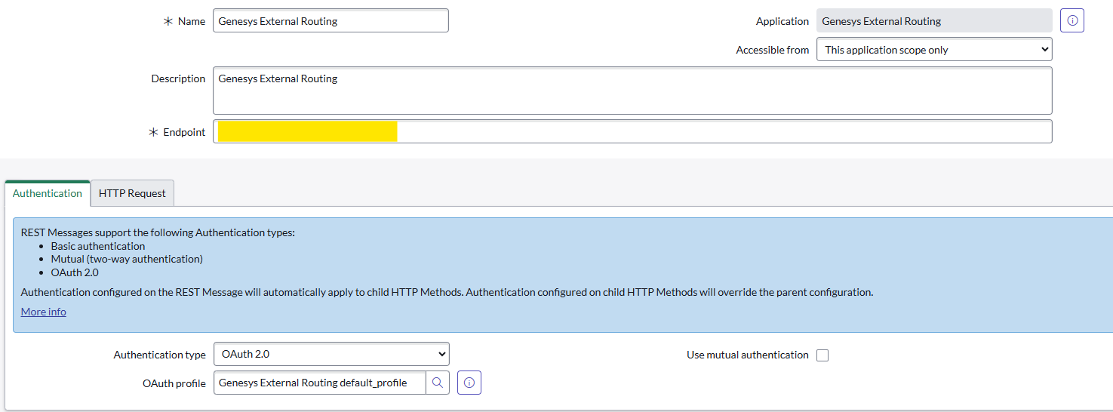
    - Ensure that a HTTP Method “Create Conversation” is created with the correct endpoint.
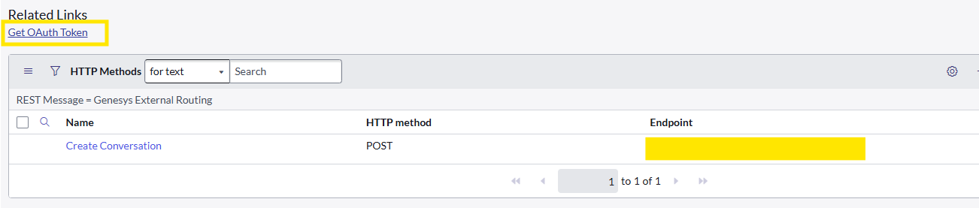
    - Click on the “Get OAuth Token”. (This is a 1-time configuration process ).
  - Verify Presence state is enabled for service channels.
    - Navigate to All -> Advanced Work Assignment -> Presence State
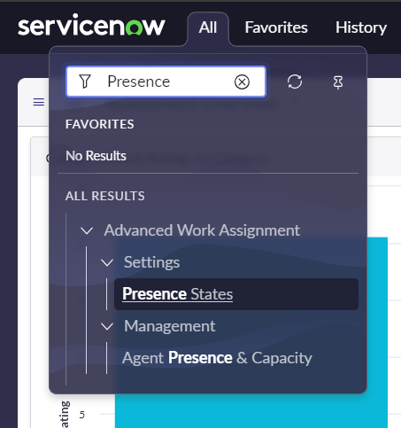
    - Click on “Available” and ensure Active & Available to receive work items are selected. Also, ensure relevant service channels are selected.
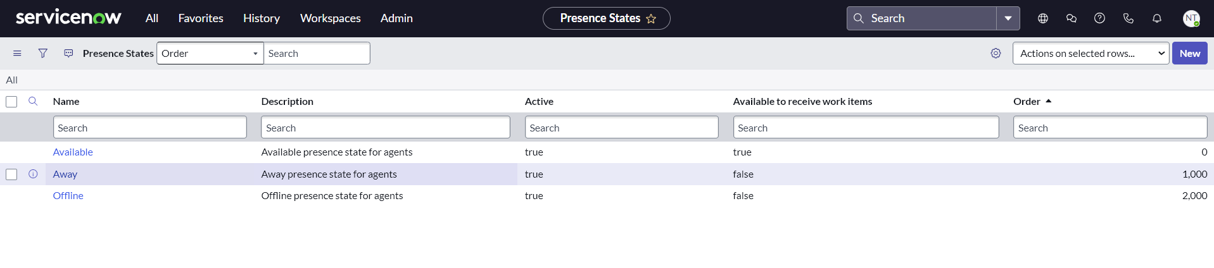
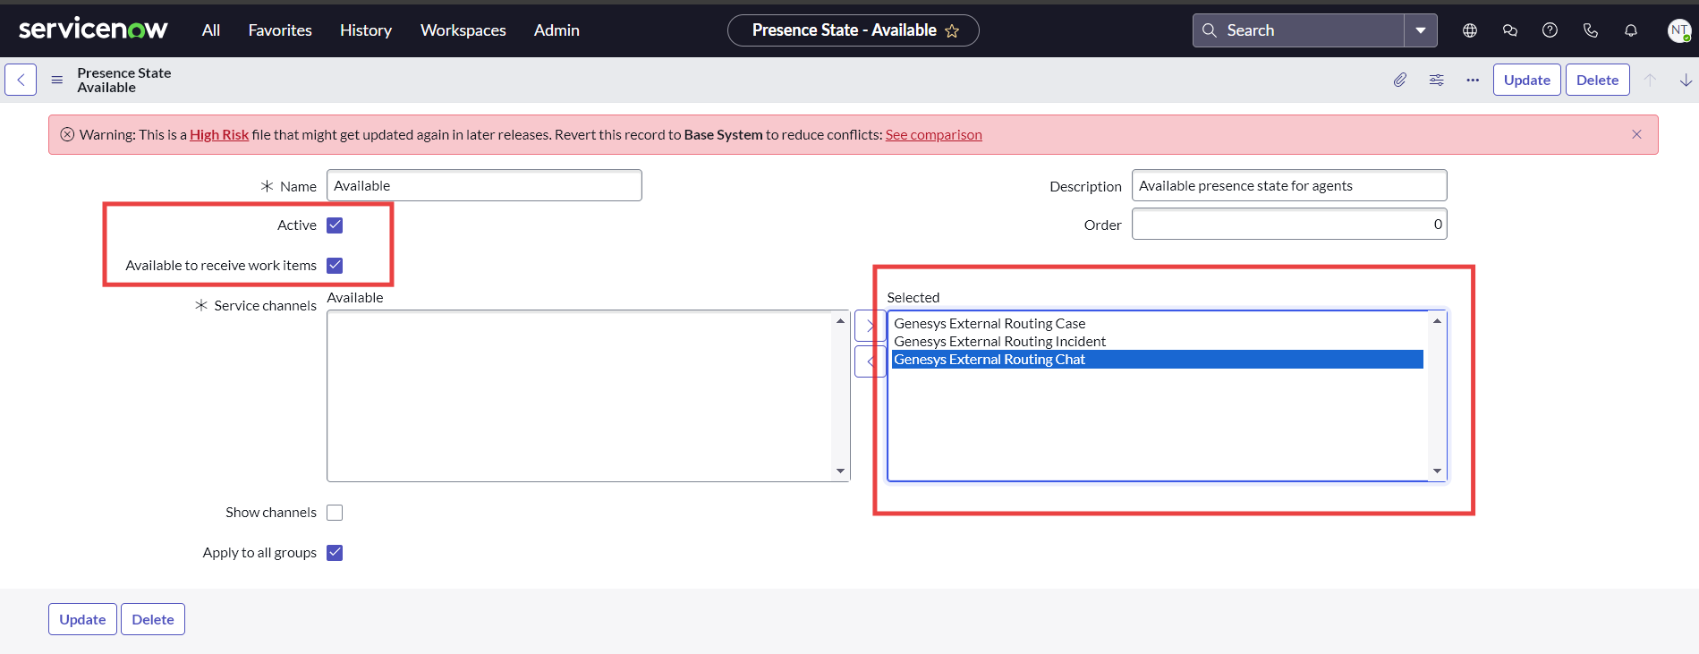
  - Go to All -> System Applications -> Application Cross-Scope Access. Create a cross scope record in the scoped application ‘Genesys Cloud Connector’ by clicking on ‘New’ button and enter the values as in the below screenshot.
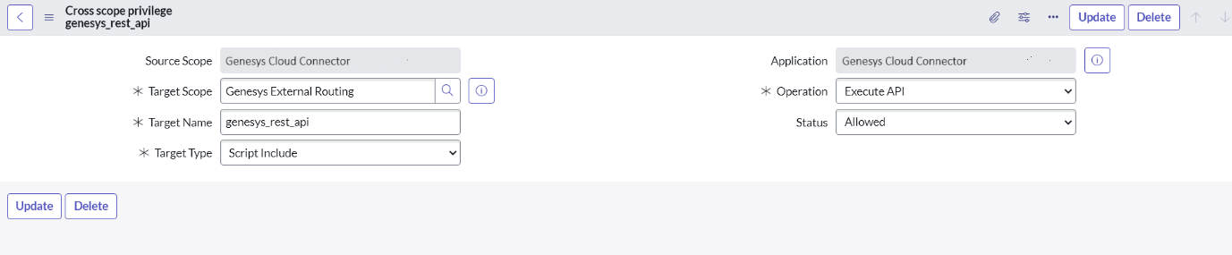
  - Refresh the page and search for "Genesys External Routing" in the Filter Navigator. You will find the necessary tab displayed in the navigator.
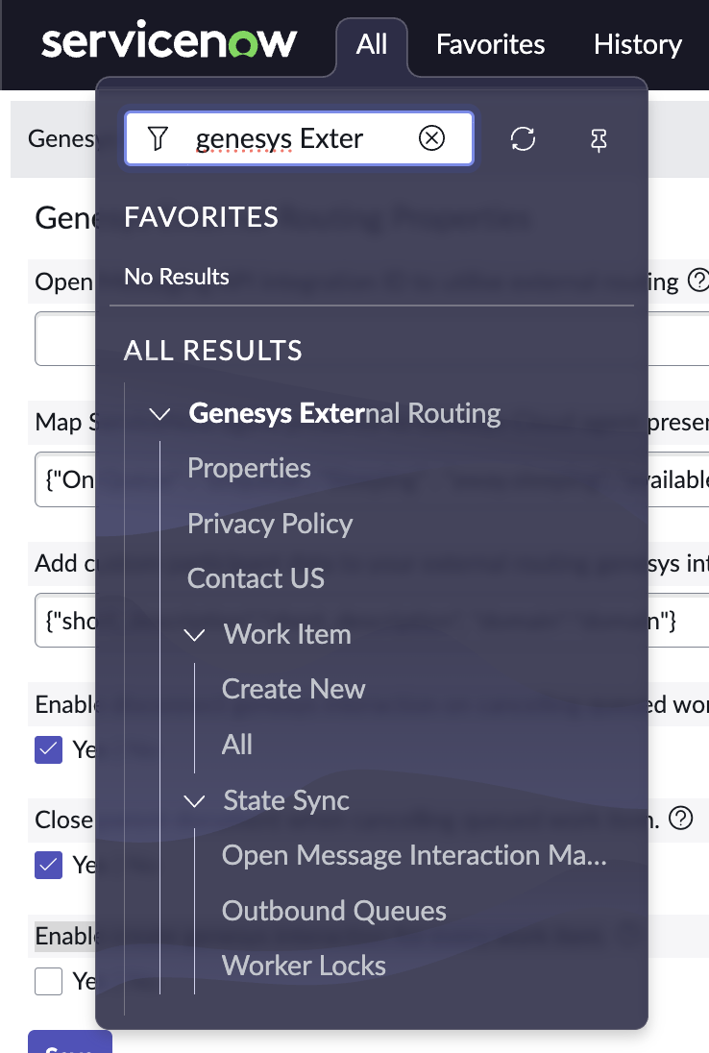
  - Modify the Genesys External Routing properties to align with the agent presence sync and task automation requirement.
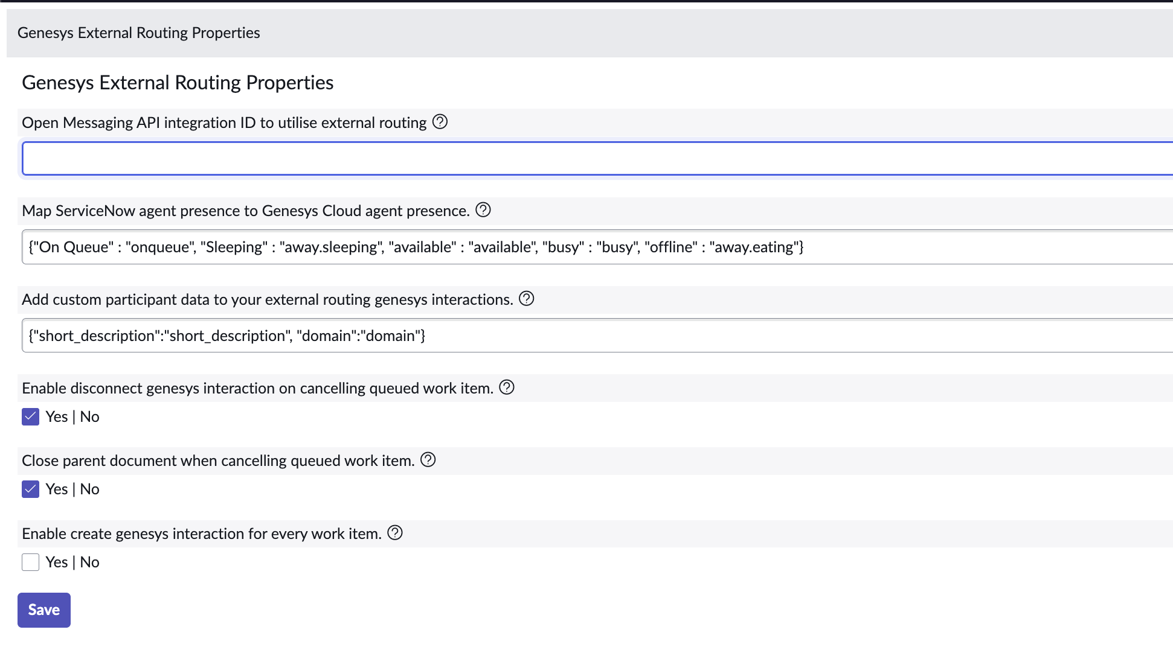

Properties | Details
Open Messaging API integration ID to utilise external routing | This is a required field to enable External Routing.  It is the uuid of the messaging platform created on GC. (refer 4.1.5)
Map ServiceNow agent presence to Genesys Cloud agent presence. | Optional field.  With this property, map an agent presence in ServiceNow workspace to reflect a corresponding presence in Genesys as configured.  ServiceNow AWA workspace can be configured to have custom Agent Presence States. Genesys Cloud similarly has multiple agent presence states. Customer can map ServiceNow presence states to show corresponding agent presence state in GC and vice versa.  Customers need to provide with an object string with key as the ServiceNow presence state and value as the corresponding GC presence state.  Note: Agent presence state “Available” in Snow workspace will always map to “On Queue” in Genesys Cloud.  Default configuration is:  {  “Available”: “onqueue”,  “Away”: “Away”,  “Offline”: “Busy”  }
Add custom participant data to your external routing Genesys interactions. | Optional Field.  The connector now supports injecting custom ServiceNow field values as participant attributes on the Genesys Cloud Open Messaging interaction at creation time.  Each key is the desired Genesys participant attribute name, and each value is the ServiceNow field name to read from the work item or its parent document.  The connector will resolve each field from the work item record first, then fall back to the parent document (case/incident/interaction). If a field is not found, the value `"no value found"` is sent.  Example:  {  "short_description": "short_description",  "domain": "domain"  }
Enable disconnect Genesys interaction on cancelling queued work item. | When a queued work item (one that has not yet been accepted by an agent) is cancelled in ServiceNow, the connector now automatically disconnects the corresponding Open Messaging interaction in Genesys Cloud.  Default Value : true
Close parent document when cancelling queued work item. | Enable the property (`true`/`false`) to also cancel the parent ServiceNow record when a queued interaction is cancelled.  Default Value: false
Enable create Genesys interaction for every work item. | By default, if a Genesys Open Messaging interaction already exists for a given document (case/incident), the connector will not create a duplicate. It updates the existing interaction map record with the new work item reference instead.  To override this and always create a new interaction per work item, set the property to true.  Default Value: false
Properties configuration page

- Support and Troubleshooting
Custom Application Support service is provided by Genesys Professional Services in concert with the Customer Care organization as a seamless process managed through a single point of contact, the Customer Care support interface, and offered through a variety of channels including phone, email, and web.
Genesys External Routing Support Guide

  - Service Level Agreement Definition
Custom Application Support process and SLA’s are defined here.
  - Troubleshooting
    - In case of configuration issues, error messages will be displayed in browser logs, providing relevant information to correct configuration values. When submitting a case with Genesys, please ensure to share browser and console logs for further investigation.
    - To troubleshoot the embeddable widget, refer to the troubleshooting guide available at: https://help.mypurecloud.com/articles/troubleshoot-the-genesys-cloud-embedded-clients/

End of Document

